MGGH RUNNING FOOLS 5K ROUTE
Water station
Start & End
STARTING AT THE MGGH BUSINESS OFFICE ANNEX
April 1st, 2022
200 S. “A” St. Bldg 8 (faces 1st St.)
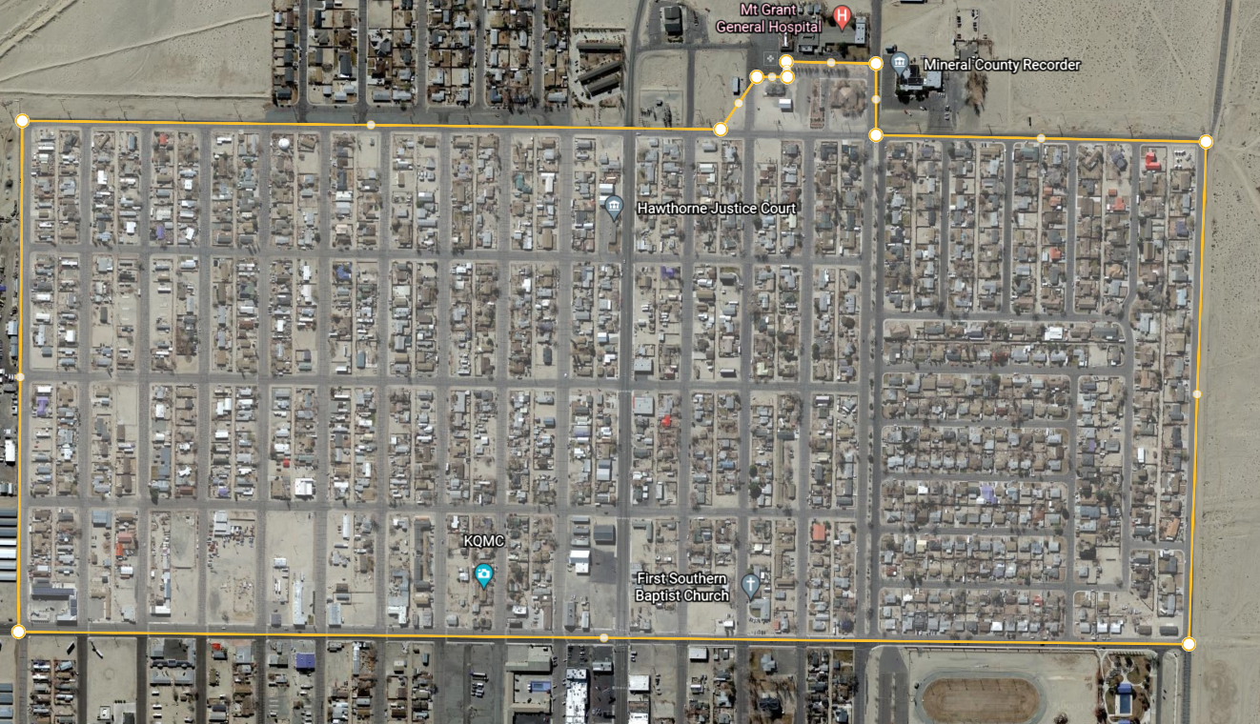
Hawthorne, NV
O St.
1st. st
5th St.

